Carson Stark

January 12, 2016

Osmosis Lab

Lab Partner: Daniel Kutch

**Osmosis Lab Introduction**

The purpose of this lab is to visualise the effects of osmosis and diffusion through potatoes. It will also show how cells react to different types of solutions, such as hypertonic and hypotonic.

The solvent is the water, and the solute is the sugar. The water will be dissolving the sugar inside and outside the potato, trying to evenly disperse itself. Potatoes are selectively permeable, kind of like cells. This means that only certain things can go through it.

After the potato absorbs the water, we will be placing it in hypertonic and hypotonic solutions. When a solution is hypotonic, it is lacking in a certain substance. When a solution is hypertonic, it is the opposite. In a hypotonic solution, water will leave the cell. The way this affects the potato is that In a hypertonic, water will flow into the cell. This happens because cells want to be isotonic, which is where there is equilibrium inside and outside cell.

In conclusion, the purpose of this lab is to visualise the effects of osmosis and diffusion through potatoes. It shows the way cells absorb and lose water and other simple materials and the effect it has on the size and mass of the cell.

**Hypothesis**

If the potato is placed in a hypotonic solution, then it will grow larger.

**Procedure**

1. Mark each beaker tube
2. Place 10 ml of solution into each beaker tube
3. Put potatoes into each beaker
4. Allow it to sit for 24 hours
5. Remove potato and measure mass
6. Obtain % mass change
7. Clean up
8. Analyse data

**Data**

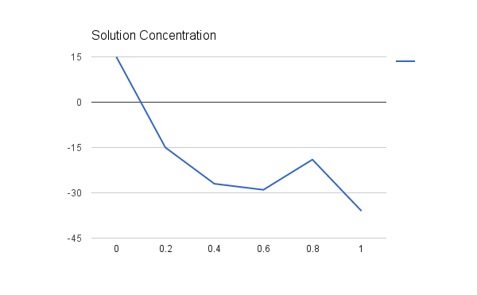

Applied Formula

Final mass - initial mass x 100

Initial

Drawings

insert the drawings here.

**Conclusion**

1. Did the data support the hypothesis? The data was supported by the hypothesis.
2. What happened in each environment?When the potato was in a hypertonic solution, it got smaller. When the potato was in a hypotonic solution, it grew larger. This is because the solute in the water can’t go through the semipermeable potato, and the water is attracted to the solute. When there’s more of the solute, more of the water is attracted to the solute, so the potato has less mass.
3. What part of the graph shows the potato in an isotonic environment? The part of the graph above the line shows this.
4. What was the dependent variable? The dependent variable we used was the size of the potatoes before and afterwards.
5. Explain how the lab shows homeostasis. In order to reach homeostasis, the water moves to the solute.